**EXPLORATORY DATA ANALYSIS**

**CSE3040**

WINTER SEMESTER 2024-25

REVIEW-1

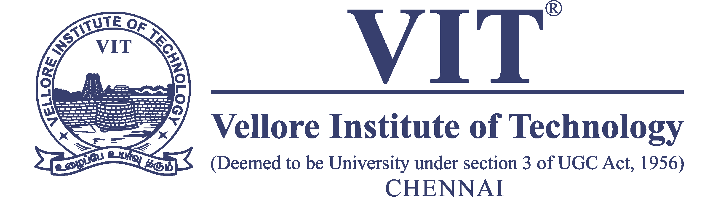

**TEAM NAME: -**

B

**TEAM MEMBERS: -**

MADHU SARASWATI TAMMANA (23MIA1003)

AKSHAT KUMAR (23MIA1110)

SANJAY CHAUHAN (23MIA1124)

**GUIDED BY: -**

ASNATH VICTY PHAMILA Y

**Title: - Understanding Global Economic Trends: A Data-Driven Approach**

**SDG: -**

**SDG 8: Decent Work and Economic Growth:** This goal focuses on promoting sustained, inclusive, and sustainable economic growth, full and productive employment and decent work for all.

**Description: -**

SDG 8 aims to create a world where everyone can thrive through meaningful and fulfilling work. It focuses on fostering **sustained, inclusive, and sustainable economic growth**, meaning economic progress that continues over time, benefits everyone, and does not harm the environment.

Furthermore, SDG 8 strives for **full and productive employment** where everyone who wants a job can find one, and those jobs are meaningful and contribute to society.

Finally, the goal emphasizes **decent work** for all, ensuring fair wages, safe and healthy working conditions, equal opportunities for everyone, and the right of workers to organize and collectively bargain for better conditions.

SDG 8 seeks to create a world where work is not just a means of survival, but a source of dignity, fulfillment, and opportunity for all.

**Abstract: -**

"This project aims to analyze global economic trends and their implications for achieving Sustainable Development Goal 8: Decent Work and Economic Growth. Utilizing a dataset comprising GDP data for 229 countries, with a focus on agricultural, industrial, and service sector contributions, this research will explore key aspects of SDG 8, including sustained and inclusive economic growth, full and productive employment, and decent work conditions. The analysis will delve into the relationship between economic growth, sectoral contributions, and employment trends, aiming to identify patterns, disparities, and potential challenges in achieving sustainable and equitable economic development worldwide."

This abstract provides a concise and informative overview of our project, effectively capturing its core objectives and significance.

**Dataset: -**

Link: -

<https://www.kaggle.com/datasets/rajkumarpandey02/list-of-countries-by-gdp-sector-composition>

Description: -

The dataset comprises economic data for 229 countries, providing insights into their Gross Domestic Product (GDP) and the sectoral contributions of agriculture, industry, and services.

**Key features of the dataset include:**

* **Comprehensive Coverage:** Encompasses a wide range of countries, offering a global perspective on economic trends.
* **Key Economic Indicators:** Includes crucial data points such as:
  + **GDP (Gross Domestic Product):** A measure of the total value of goods and services produced within a country.
  + **Sectoral GDP:** Provides a breakdown of GDP contributions from agriculture, industry, and services, revealing the economic structure of each country.
* **Global Comparability:** Allows for cross-country comparisons of economic performance and sectoral development.

This dataset serves as a valuable resource for analyzing global economic trends, identifying development disparities, and investigating the relationship between economic growth, sectoral composition, and key aspects of SDG 8, such as employment and decent work.

This description provides a concise overview of the dataset and its potential for analysis within the context of SDG 8.

**References: -**

**1. Dataset:** <https://www.kaggle.com/datasets>

**2.** World Bank. (n.d.). DataBank. Retrieved from <https://databank.worldbank.org/>

**3.** Hands-On Exploratory Data Analysis with Python by Aurélien Géron

**4. UN Publications:** United Nations. (2015). Transforming our world: The 2030 Agenda for Sustainable Development.

**5. Python for Data Analysis:** Data Wrangling with Pandas, NumPy, and IPython by Wes McKinney